**STABILITY OF COLUMNS**

**INTRODUCTION:**

Structural members that support compressive axial loads are called Columns. A column in structural engineering is a vertical structural element that transmits, through compression, the weight of the structure above to other structural elements below

**OBJECTIVE:**

To determine the Column stability using boundary conditions.

**THEORY:**

In general if a beam element is under a compressive load and its length is an order of magnitude larger than either of its other dimensions such a beam is called columns. Due to its size its axial displacement is going to be very small compared to its lateral deflection called buckling.

The loads that are coming to column are more than the weight of the column the buckling factor takes place. A column can either fail due to the material yielding, or because the column buckles, it is of interest to the engineer to determine when this point of transition occurs.

Consider the Euler buckling equation



Here L = Length of the Column (ft)

E = Young’s Modulus (Ksi)

I = Moment of Inertia (mm^4)

Because of the large deflection caused by buckling, the least moment of inertia *I* can be expressed as



A is the cross sectional area

*R* is the radius of gyration.

The critical loads for the different sections given by

1. Pinned-Pinned column buckling load for Length L = L

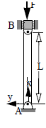

C:\Users\das\Desktop\1313.png

1. Fixed-Fixed column buckling load for length L = (L/2)^2

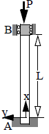

**C:\Users\das\Desktop\23232.png**

1. Fixed-Pinned column buckling load for length L = (L/√2)^2

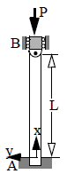



4) Fixed-Free column buckling load for length L= (L/2L) ^2

C:\Users\das\Desktop\76899879.png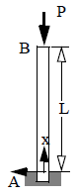

**Critical Column Stress:**



Dividing the buckling equation by A, gives

σ*E* is the compressive stress in the column and must not exceed the yield stress σ*Y* of the material, i.e. σ*E*<σ*Y*, *L / r* is called the slenderness ratio, it is a measure of the column's flexibility

**Critical Buckling Load:**

Pcrit is the critical or maximum axial load on the column just before it begins to buckle E Young’s modulus of elasticity

I *least* moment of inertia for the columns cross sectional area.

L unsupported length of the column whose ends are pinned

**Input values given based on the condition:**

1) Young’s modulus: ___________( ksi)

2) Area moment of inertia (I): _________ (mm^4)

3) Length of column (L): ___________ (ft)

4) Boundary conditions

**OBSERVATION:**

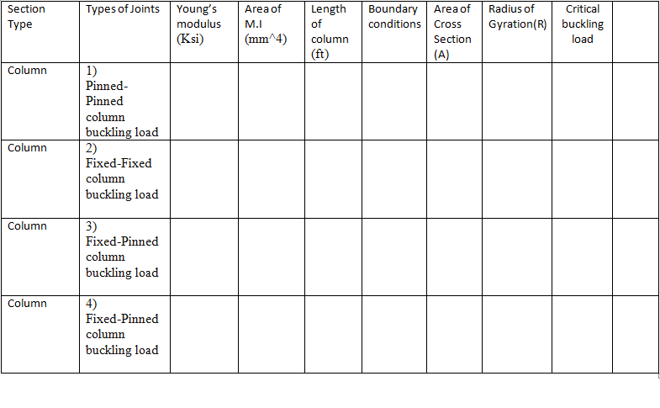

**Quiz:**

1. The buckling load formula for column?
2. Number of boundary conditions that are present in columns
3. What are the constant values that doesn’t change in calculation of Pcr

**References:**

Mechanics of materials by Dr.B.C.punmia

Stability of columns by YI Nagornyi Prof

Design of steel structures by Prof.S.R.Satish Kumar and Prof A.R.Santha Kumar